STG-455 Weekly Status Update
Production Release Engineering for a Cross Platform Mobile Application

Project Description
Studio XE is a software platform used by legal, financial, and health care firms to run daily operations, including accounts, documents, messaging, referrals, and tasks. Its mobile application is built with React Native, Expo, and TypeScript and covers 19 screens. The application runs and demonstrates well but is not ready to ship: it has no automated tests, no crash or error reporting, and no release pipeline, and it is not available in either app store. This project builds that missing release infrastructure. Term One produces the release and verification infrastructure and gets the application accepted into Apple TestFlight and Google Play internal testing. Term Two adds offline capability and a shared component definition so the web and mobile applications stay consistent.

Project Status Summary Percent Complete 2%
The team is in the early stages of Term One, and overall project completion is 0%. NDAs have been completed, and the project requirements are being analyzed along with the technologies, skills, and tools that must be learned before development begins. The main risk is a delay in receiving the Studio XE application and project resources, which would postpone the start of development. Additional risks are listed in the Risks section.

Timeline Snapshot
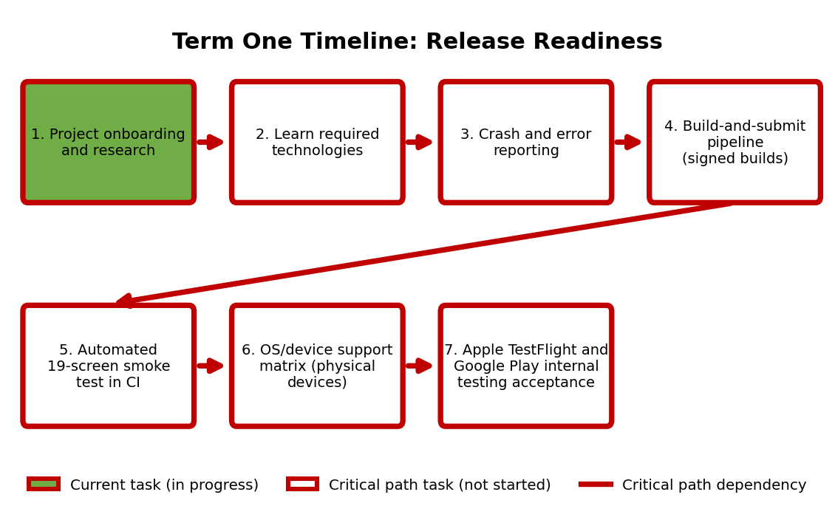

The team is in the planning stages of Term One. NDAs have been fulfilled, and the current application, required technologies, and Term One requirements have been analyzed. The critical path, marked in red in the diagram, runs from onboarding and research through learning the required technologies, crash and error reporting, the build-and-submit pipeline, the automated 19-screen smoke test in continuous integration, and the OS/device support matrix, ending with internal testing acceptance in Apple TestFlight and Google Play. Onboarding and research is the current task. Because store review timing is controlled by Apple and Google, a minimal build will be submitted to both stores within the first six weeks so that review delays are discovered early.

Current Concept
The Studio XE application has not been made available to the team yet, so a screenshot of the current prototype is not available. Until it is, the diagram below shows the planned Term One concept: source code passes through a continuous integration smoke test of all 19 screens, EAS Build produces signed iOS and Android builds, and EAS Submit sends them to Apple TestFlight and Google Play internal testing. Crash and error reporting covers all build configurations, and the OS/device support matrix is validated on physical devices. Once the application is available, the team will capture the current prototype and use it as the baseline for all future change.
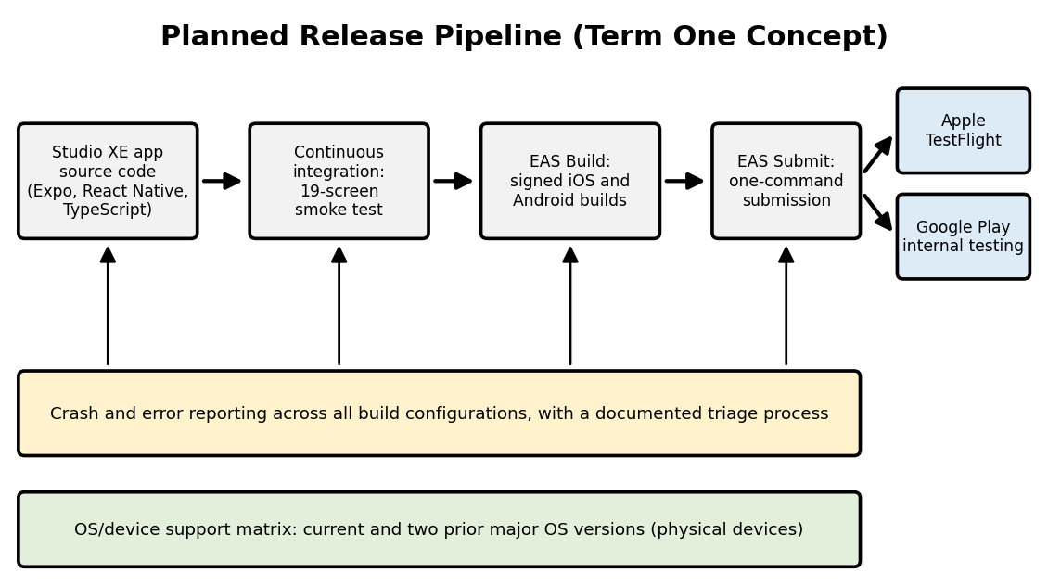

Accomplishments and Learning
Planned from last week
- Complete all NDAs required
  - Complete. All required NDAs have been completed.
- Start onboarding to the project and get an understanding of the project need
  - In progress. The Studio XE application and project resources have not yet been provided, which limits the understanding of the project need until access is granted.
- Determine skills and technologies needed for Term One
  - In progress. Requirements analysis is underway, but the full list of skills and technologies depends on access to the application and project materials.
Unplanned
  - No significant unplanned tasks or findings at this time.
Findings / Lessons Learned
- The initial phase of the project depends on understanding the current Expo/React Native app and deployment pipeline before implementation begins.
- The team must gain an understanding of cross-platform testing, crash and error reporting, mobile build and deployment pipelines, continuous integration, and automated testing.

Work Planned for Next Week
- Critical Path: Contact the business representative to gain access to project information, development tools, existing project materials and the Studio XE app required to start the project. This also includes gaining access to any other information that is required to start the project.
- With access gained, examine the current app architecture and project requirements.
- Determine the technologies, tools and development approaches that will need to be mastered prior to development commencing.
- Determine the requirements for readiness of the Term One release. This includes OS/device testing, build and submit process, automated smoke testing, crash and error reporting and any other requirements.
Milestone: Have completed initial project integration and have gained access to all information and resources required to start development.

Risks
- Delays in receiving the Studio XE application and project resources could prevent development from starting and delay the project. Mitigation: contact the business representative immediately and follow up regularly until access is granted.
- Limited experience with the project tools and technologies (Expo, React Native, EAS, continuous integration, and mobile testing) could require extra learning time before implementation. Mitigation: begin research during onboarding and prioritize the technologies needed for the critical path.
- Incomplete or unclear project requirements could cause ambiguity about the required product. Mitigation: document assumptions and confirm them with the business representative.
- Integration problems with cross-platform device testing, crash reporting, automated testing, or the release pipeline could require extra development time. Mitigation: build and test each piece incrementally, starting with a minimal build.
- App store review timing is controlled by Apple and Google and could delay TestFlight and Google Play acceptance. Mitigation: submit a minimal build to both stores within the first six weeks so that review latency is discovered early.

Deliverables and Milestones

Milestone | Planned | Forecasted | Actual | Status
Complete project onboarding and NDAs | 10/02/2026 | 10/02/2026 | 10/02/2026 | Completed
Obtain Studio XE application and project resources | TBD | TBD | — | Pending
Complete requirements and technology review | TBD | TBD | — | Pending
Establish development plan | TBD | TBD | — | Pending
Deliverable | Planned | Forecasted | Actual | Status
Crash and error reporting across all build configurations, with a documented triage process | TBD | TBD | — | Not Started
Build-and-submit pipeline producing signed iOS and Android builds from a single command | TBD | TBD | — | Not Started
Automated 19-screen smoke test running in continuous integration | TBD | TBD | — | Not Started
OS/device support matrix covering the current and two prior major OS versions, validated on physical devices | TBD | TBD | — | Not Started
Apple TestFlight acceptance | TBD | TBD | — | Not Started
Google Play internal testing acceptance | TBD | TBD | — | Not Started

Attachments
N/A

Approvals:

Team Role | Print Name | Signature | Date
Team Lead | Gabriel Veltri | Gabriel Veltri | 10/2/2026
Team Member | Fernando Hernandez Leon | Fernando Hernandez Leon | 10/2/2026
Team Member | Austin Kelemen | Austin Kelemen | 10/2/2026
Team Member | Luke Hoyle | Luke Hoyle | 10/2/2026

